Project Name: Operationalize Proof of Performance for Material Co-Marketing Spend

Project Manager (BRD DRI): Stephanie Cruz

Business Sponsor/Stakeholder: Brandon Solberg

Document Status (underline one): [Draft] [Proposed] [Validated] [Approved]

Date Last Updated: 2/28/2025

Target Launch Date: 4/1/2025

| Related Documentation Links: [Operationalize Proof of Performance Requirements](https://docs.google.com/presentation/d/1F0O1scSCp08i-_g9QNeyU_mb9HqnqYfJdds4IYTUGJ8/edit#slide=id.g3311fce5bc0_0_6)  [Co-Marketing Funds Program Terms - TEMPLATE](https://docs.google.com/document/d/1JN5KObuRQyvLPeClAVMM-nZoaDO6WEh245urbaJXLxA/edit?tab=t.0) | |
| --- | --- |
| Task #: | |
| Approvers: [Brandon Solberg](mailto:brandonsolberg@meta.com)[Katie Simmons (AR/VR)](mailto:katiesimmons@meta.com)[Elisa Tran](mailto:elisa.tran@meta.com)[Michelle Chuang](mailto:michellechuang@meta.com) | |

## Table of Contents

1. Project Goals & Objectives
2. The Present Process
3. The Proposed Process
4. Business Requirements
5. Open Items

## Project Context, Goals and Objectives:

## Project Background:

The current process for documenting co-marketing agreements between Meta and retailers lacks consistency, with details scattered across various formats such as emails, PowerPoints, and texts. Furthermore, there is no standardized method for collecting proof of execution and performance, nor is there any enforcement mechanism in place. We propose starting with spend > and equal to $250k. In 2024 and 2025, co-marketing spend activities >$250k accounted for 4.4% of co-marketing spend.

This lack of transparency and accountability makes it challenging to accurately assess the return on investment (ROI) of large marketing spend. As a result, marketing budgets may not be allocated efficiently, and negotiations with retailers may not be optimized.

By implementing a more structured and standardized approach to documenting co-marketing agreements, we can gain better insight into the ROI of marketing spend. This will enable us to make more informed decisions about budget allocation and negotiate more favorable terms with retailers.

## Problem Statement:

The current Operationalize Proof of Performance for Material Co-Marketing Spend process lacks the ability to document co-marketing agreements between Meta and retailers and capture information from retailers to assess ROI. This leads to:

* Lack of accountability from retailers, as they’re not held accountable to agreed terms
* Increased risk of errors, miscommunication, and non-compliance
* Lack of informed decision making when allocating co-marketing budgets
* Lack of data shared for analysis

## Business Benefit:

Injecting structure and standardizing the process of documenting comarketing agreements between Meta and retailers will result in considerable business impact resulting in

* Improved accountability, accuracy and compliance
  + By providing a centralized location for storing agreements, the goal is to increase efficiency with real-time availability of information and enhanced accountability and compliance.
* Better budget allocation decisions and improved ROI
  + By making data driven decisions, the goal is to improve ROI and better performance throughputs
* Enhanced data analysis and improved visibility
  + The goal is to increase ROI by 5% for spend >= $250K in 2025. There is no current ROI measurement available.

## Business Justification:

The current process lacks accountability and transparency, as there are gaps in proof of specific activities and performance. This also makes it difficult to track the ROI of our marketing spend. Without a standardized process and system in place, we’re unable to understand where funds are being allocated.

## Business Impact:

* Visibility into retailer activity and ROI, to better invest in effective marketing strategies and partnerships
* Optimize marketing spend and improve relationships with retailers
* Hold retailers accountable to agreed terms of execution and data sharing

## The Present Process:

1. Upon creation of comarketing activity, CM number is automatically generated in Salesforce
2. Upon approval of comarketing activity, CM number is transmitted to claims tool
3. Today, there are no standardized letters for comarketing, so CMMs will communicate the approved amount & provide a CM number to retailers through various formats (email, text, PPT slide, etc.)
4. When a claim is submitted by a retailer, the Claims team will manually look at and process basic info (alignment of dates, reseller name, amounts, products, activity type, etc.). Basic info flows from Salesforce into Claims@ tool. Currently, there is no standardization around type of documentation required
   1. EMEA has a Sharepoint and there are specific questions asked for that team
5. After the claim is approved & paid, Salesforce will automatically generate a link in the comarketing spend area. This link will direct users to the proof of performance on the claims tool
   1. There is no specific format a partner provides this information in - below are examples of historic PoP:
      1. SAM/CMM enters into SFDC: [Salesforce Connector](https://fb.lightning.force.com/lightning/r/CoMarketing__c/aMw8V000000000QSAQ/view)
      2. Screenshot: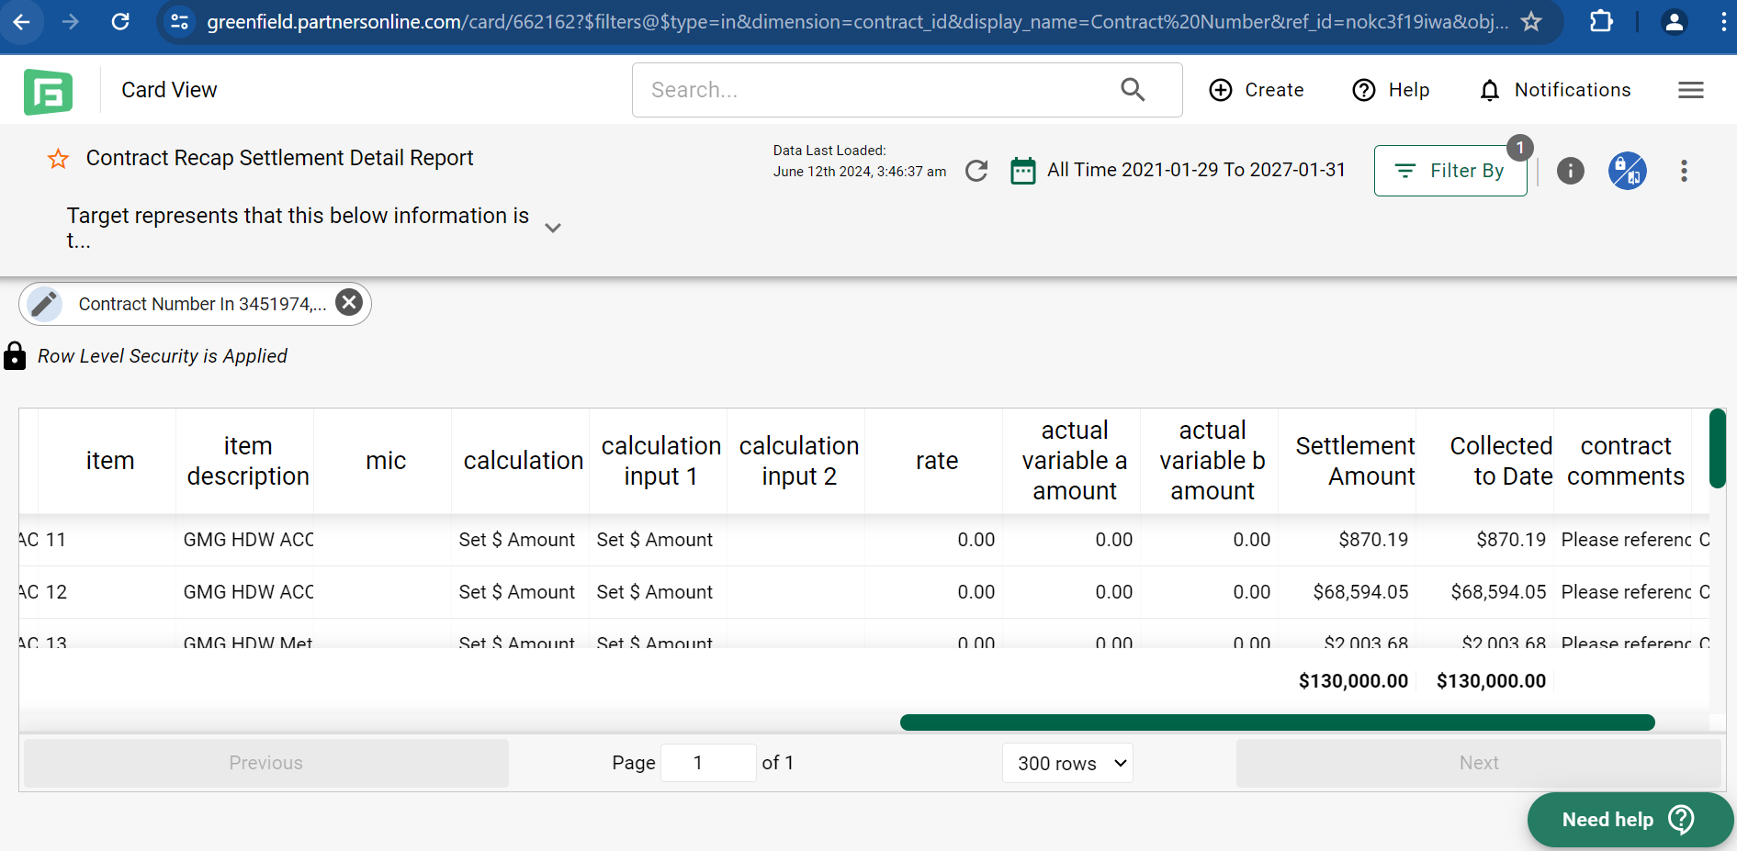
      3. [PDF](https://cdn.fbsbx.com/v/t59.2708-21/473640490_2270121356699001_5340630435079751050_n.pdf/AMZ.pdf?_nc_cat=108&ccb=1-7&_nc_sid=2b0e22&_nc_ohc=eCH3tXyYBYEQ7kNvgFWTaPX&_nc_zt=7&_nc_ht=cdn.fbsbx.com&_nc_gid=AelO1b7mLrmf0AbEl6ARnc7&oh=03_Q7cD1gHc610gaNwg2DUohK7xZXzhlF2mCSI6D19TZhvNJkgkxQ&oe=67949A30&dl=1)
      4. [Google Sheet](https://fb-my.sharepoint.com/:x:/g/personal/wangrita_meta_com/EQ981EF5HaZKutVbwKaR3RsBS-8WUOq9XBb-bNOVu056PQ?e=vAJ33y)

## The Proposed Process:

The proposed process is broken down into two parts:

1. Documentation & Process Standardization
2. Claims@ Integration Build

For purposes of H1 2025, the team will focus on part 1, documentation & process standardization.

**Documentation & Process Standardization**

1. CMMs will create co-marketing headers in SFDC
2. When a header is >=$250k, a field will appear to attach the co-marketing agreement and the agreement template will appear for CMMs to download. This will allow the CMM to be notified of the need to upload the agreement and easily access the template to be filled out.
   1. A header should allow for multiple attachments if the activities are varied. However, only one document upload should be required to submit for approval.
3. CMM must attach agreement before submitting the co-marketing entry for approval
   1. If CMM does not submit a co-marketing agreement for approval, an error will appear: Given your co-marketing amount is >=$250k, you must submit a retailer agreement for approval.
   2. Note: A standard agreement will be provided to all CMMs. This agreement letter will have a pick list to include the relevant information in their agreement form. A signature is not required from the retailer.
4. CMM must then check 2 check boxes, if the answer is “yes”
   1. Check box 1 should say: “Has the co-marketing agreement been shared with the retailer?” – Mandatory field to check for submission
   2. Check box 2 should say: “Were goals outlined in the agreement validated by the Demand Planning team?” – Optional field to check for submission

**Claims@ Integration Build.** **P1 - Proof of Execution & Performance:** require and enforce retailers to send proof of execution and proof of performance (e.g., open text field, attachment, new fields, etc.)

1. **P2 - Enforcement:** To start, retail teams will use data for negotiations and future co-marketing agreements. Medium to longer term, CMMs are required to approve payment of this spend and will evaluate proof of performance before they do.

## Business Requirements:

*Critical - Must be in scope*

*High - Should be in scope*

*Medium - Nice to have*

*Low - Future functionality request*

| Priority | Requirements Description |
| --- | --- |
| Critical | Agreements apply to co-marketing headers greater than or equal to $250k in reportable spend only (for fixed and accrual based co-marketing spend types). |
| Critical | Agreement must be attached on the co-marketing header in order for it to be submitted for approval. Many attachments are to be allowed but only 1 needed for submission. |
| High | Standardized agreement letter used for each retailer. This agreement letter is a template with a pick list for CMMs to edit as they see fit. This template will be available for download in SFDC. |
| Critical | Applies to all accounts. |
| Critical | If a CMM tries to submit a header for approval and does not attach an agreement, an error message appears, “Given your co-marketing amount is >=$250k, you must submit a retailer agreement for approval.” |
| High | Check box 1 available: “Has the co-marketing agreement been shared with the retailer?” (mandatory field to check for submission) |
| High | Check box 2 available: “Were goals validated by the Demand Planning team?” (optional field to check for submission) |

#### Open Items:

#### Claims@ integration build.